Livelihoods of the Santals:
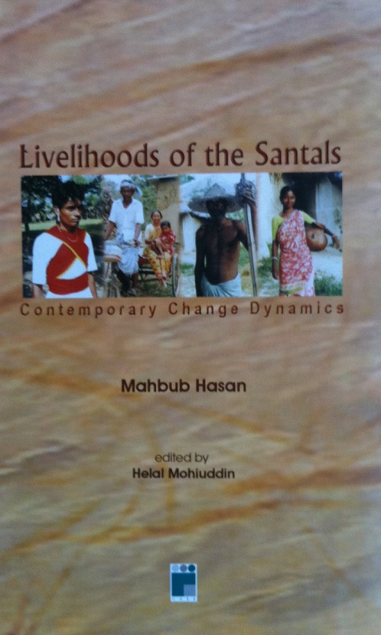
Contemporary Change Dynamics

Author: Mahbub Hasan
First Published: 2006
Publisher: Center for Applied Social Studies
Place of Publication: Dhaka

Preface

Nowadays, livelihood change of the marginalized people throughout the world constitutes one of the prime academic and development attentions. This is because globalization has continued making tremendous strides in the landscape of human livelihood since the late eighties. Development of modern communication amenities and means, mass transportation, electrification and linking of the global village through the information highway may not leave the livelihoods of the people on the fringes untouched. Therefore, the notion of diversity that once used to portray uniqueness of cultural distinctiveness of small ethnicities by now is being translated by some quarters as diversion and convergence of classical cultural entities with new cultural forms and patterns. Physical mobility of humans—even the ethnically secluded ones—has increased over the last few decades. This is an assumable fact that the economic adaptation possibilities may turn migration and intra-mixing of people on ethnic fringe into a time-bound reality.

While the above-mentioned facts still remained unattended in most anthropological literature in Bangladesh, the present study is also not an exception. It is an obvious fact that the anthropological and sociological studies nowadays need to accentuate and incorporate a much broader contemporary vision of change dynamics in cultural courses and discourses. Yet, there are scanty attempts to look through livelihoods and livelihood strategies of people under the surges of globalization and neo-modernity. While this book cannot make an overarching claim of incorporating these dynamics into research, it at least makes some hints toward looking into the trends and patterns of change. This way, it may help anthropologists and historians and cultural study practitioners to find significant change indications for future investigation and research.

Ethnographic details and ethnological outlooks about the Santals are somewhat abound in Bangladesh and West Bengal. As usual, these resourceful documents contain historical and sociological contents of the Santal livelihood. In recent times, anthropology is a cross-cutting discipline—often entailing the essence of development paradigm and applied sociological commitment. In the similar line of thought, this piece attempts to make an anthropology-development study intersection. Seemingly, the attempt is somewhat disjointed, lacking some crucial consideration like globalization-driven changes and adaptation processes affecting the Santal livelihood. Yet, the spirit of the book—thereby the commitment to look deep into the courses of change in the Santal livelihood retains the strength of classical anthropological perspective. Employment of the participation observation fashion in the field study appears to have made the study worth validating in terms of empiricist positioning of the author. The other beauty of the study is the author’s acknowledgement (somewhat a confession) about the narratives that hardly go beyond his perceptional and observational narratives.

“Intactness of expression”—no matter emic or etic—provides cultural anthropology and social history unique and exceptional intellectual identity. As in anthropological expression, editing is mostly ornamental, and rarely instrumental. Therefore, except some grammatical and conceptual modification, most of the expressions of the author is kept intact in this book. Apparently, the book investigates into the changing pattern of life styles of the Santal ethnic community of Barind tract. In fact, it also presents some ethnographic details of the Santals of the researched region. A regional picturesque, as well, is drawn consistently. More importantly, the book—being an adaptation of the author’s M.Phil thesis, contains characteristics prototypical report style in some relevant contexts.

The Barind tract covering a large part of Rajshahi district in the north-west part of Bangladesh is inhabited by a numbers of ethnic communities like Santals, Oraons, Turis, Rajores etc. along with the Bengali people. There exists a co-existing livelihood trend of the plain land ethnic communities and the Bengali people. However, the hamlets of ethnic communities are distinguishable from the hamlets of Bengali people. At places of the Barind region, villages inhabited by the ethnic communities are separable from those of Bengali population. It means that the ethnic communities exclusively inhabit in some villages, which are distinct from the villages of the Bengali inhabitants. Overall, cultural dynamics, even nowadays, provides a plethora of indicators toward the assumption that the ethnic communities, especially the Santals, settled in this area before a few millennia, and that the Bengalis are much more recent settlers migrating from different parts of Bangladesh.

The climate of the Barind region is rather extreme. It is very hot during the summer and very cold during the winter. Yet, the Diaspora attributes of the new settlers do not find it that harsh to form newer livelihood. It is a historical truth that the migrants, immigrants or emigrants often retain a common tendency in settlement practice. The first is to acquire, grab or lawful possession of land as living abode and farming means. The second is introduction of a regional economic system for long-endurable future survival and livelihood sustenance. While the indigenous system becomes institutionalized, customary, ritualistic and rigid; the invading new economic orders (introduced by the settler) often appear as forceful, dominating, dynamic, defensive and aggressive over others. This way, invading and alien new economic order becomes a dominant culture over indigenous culture and market system.

There are different historical instances that such above-stated mind-sets often resulted in violent confrontation between the ethnic culture and the settlers’ dominant cultural enforcement. However, exceptions are rarely recorded or analyzed in scholarly works. As seen in this book, there are also peaceful attempts of integration, incorporation and adaptation in newer livelihood systems. Maybe there are hidden discontents and disapproval among the ethnic people—sometime concealed as a survival strategy—yet the fact of adaptation cannot be ignored merely due to politico-sympathetic research stances.

This book, however, concentrates on the Santals’ ethnically sound adaptation of survival modes over changed contexts. It seeks to understand the changes that are taking place in their way of life and culture. It is revealed that the century-old life-style, culture-traits and societal courses of the Santals are being incorporative of timely changes. Some of them seem to have shifted from core plough-economy, stand-selling of crops and indebted-labour selling to off-farm shared-animal husbandry, modern harvesting, carpentry, earth-digging, craftsmanship, day-laboring, contract labouring and wage-migration in and outside regions. Dietary habit change is also projected as a consequence of depletion of natural sources of food. With degrading and denuding vegetation coverage, and otherwise use of lands (such as brick-fields); there is a growing and acute shortage of availability of rats, hares, squirrels and crabs; the community people seem to show a tendency of becoming part and parcel of ‘consumer economy’ (buying ready-foods). This may have future consequence in their livelihood. Yet, a check and balance is also observed in their dedicated inclination of maintaining cultural integrity through increased practice of cultural rituals and festivities. Some of them believe that if this uniqueness is compromised, the Santals would soon loose uniqueness of their identity within a short span of adaptive journey to the changes.

In this respect, this book is thought to provide newer direction to future researchers toward looking deep into ‘do’s and ‘don’t’s of adaptation as perceived by the Santals themselves.

